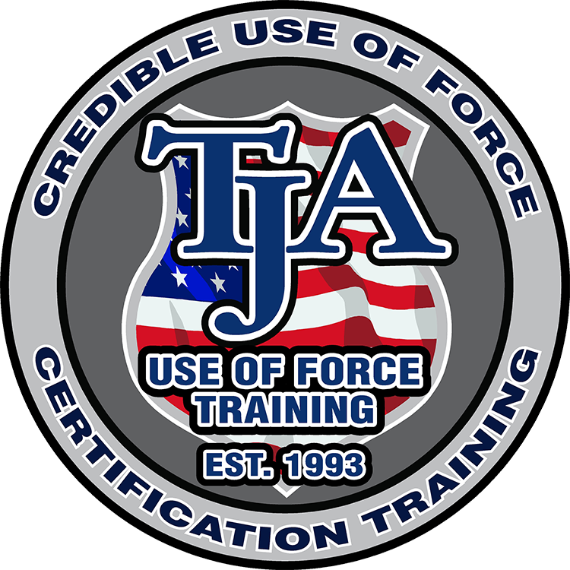

Advanced Correctional Emergency Response Team (CERT) Instructor and Use of Force Instructor Certification Course

HOSTED BY: Bradford County Sheriff’s Office



Course Location: Bradford County Sheriff’s Office
945 N. Temple Avenue
Starke, FL 32091
https://maps.app.goo.gl/iFSo4TNCkEPUBmd4A

TJA Contact:
Brian S. Clark, CEO / Chief Instructor
(717)339-7771
brian.clark@tactical-training.com
https://tactical-training.com/

Course Registration:
https://tactical-training.com/registration/

COST PER STUDENT: $1100
Includes:
- Training manual
- USB Drive with all Instructor Materials
- Emergency Response Belt
- 2oz DPS OC Spray
- Inert OC Units
- 3-year instructor certification

Each student will need to bring (5) 12 gauge flexible less-lethal munitions (Bean-Bag Rounds).

Course Dates: July 20th-24th, 2026
0800-1630hrs
Bradford County Contact:
Lt. Amanda Hinds
(940)966-3979
Amanda_hinds@bradfordsheriff.org

Course Description:

A specialized five-day, comprehensive C.E.R.T. and Use of Force Instructor Certification Course. Participants will learn how to instruct, train, and certify their own agency personnel in correctional emergency response techniques and credible use of force practices as permitted within the law.

or
Course Instructor:
Brian S. Clark, Owner CEO of TJA Use of Force Training, LLC, Master Instructor of TJA courses, twenty-three years. He has established his vast knowledge and credibility in the Use of Force over his thirty-year career in the military and corrections.

Course Topics Include:

- Use of Force parameters and associated Federal laws
- Use of Force Training Model & documentation best practice
- Confrontational Avoidance Techniques
- Establishing a C.E.R.T. team consistent with national standards
- Control and Restraint Techniques
- Oleoresin Capsicum Aerosol Weapons
- Emergency Response Belt
- Cell Extractions and Disturbance and Riot Control
- 12 gauge Less-Lethal Munitions and Diversionary Devices / Royal Arms FBG-MK4
- Edged Weapons and Spontaneous Defense
- Practical Tactical Demonstration and scenario-based exploration
- Correctional facility and environmental planning and logistics and related threat assessment

Methods of Payment:
Purchase Orders / Checks / Credit Cards



